**Topic Bulletin – 14th June 2024**

Dear Parents and Carers

It's been an exciting and busy fortnight to start summer term, both in school as well as taking our learning beyond our school gates. Across the school, several year groups have been treated to a series of educational and enriching school trips which have provided hands-on learning opportunities and rich experiences. In addition, our school have had several different teams competing in various sporting events and competitions. Every time our children represent our school out and about, they have demonstrated dedication and passion for learning as well as epitomising our school values.

Please make sure you have a look at the Learning Overviews at the end of this bulletin to find out what your child will be learning this half term.

**Arts Week…**

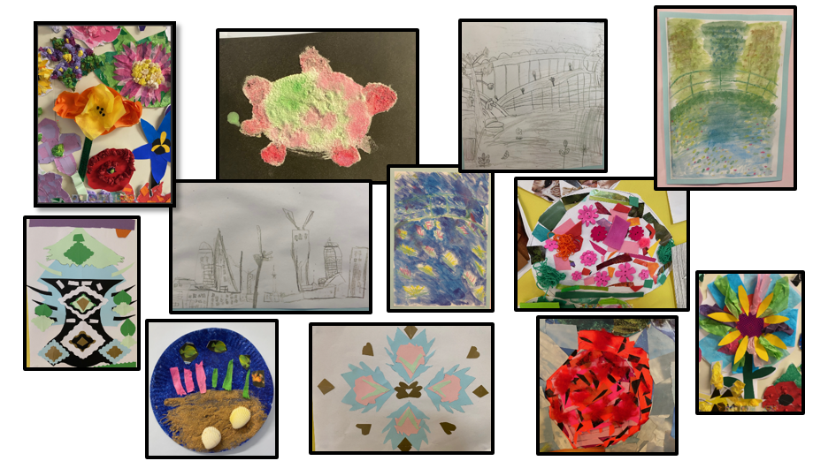We have had a fantastic start to the term with our Around the World Arts Week. Each class has chosen a part of the world to look at the art and music that is typical of that area – developing their understanding of different cultures and ***Showing kindness to all***. Across the school, we now have beautiful displays of vibrant and imaginative work from all across the world, showing a range of art techniques form mixed-media collage, sketching, digital media and watercolours. A huge thank you to all of the adults in school for the enthusiasm and time put into creating a fantastic enrichment week for the children. Also to Miss Knight and Mrs Stickland as Art and Music leaders for developing this work across the school, really ***Making a Difference***.

**Friday Sing-along…**

Last Friday afternoon, it was fantastic to welcome so many of you to listen to the KS1 and EYFS sing-along, a lovely opportunity to ***Be Confidently Me***. I’m sure you would all agree that the singing and dancing was just wonderful! They had also worked so hard with their grown ups to learn the sign language for the songs. Thank you so much to those who were able to attend, creating a super audience for the children.

**Swap Shop**

As we near the end of the school year, please can you keep in mind donating any uniform or PE kit your child has grown out of. Please remember it needs to be ***in good, clean condition*** *– items you would gladly take home and use for your own children.*

We will have tables of clothing outside the front of the school on Monday 22nd and Tuesday 23rd July for families to come and collect anything they need ready for September. Please bringing items into the school office or drop them off on those first 2 days of the summer holidays.

I am looking forward to all the wonderful experiences and achievements that the summer term brings. With even more school trips and visitors planned, as well as the additional excitement of Sports Day and the Summer Fete it’s sure to be a memorable end to the school year.

As always, please remember that we have an open-door policy, so let us know if we can help in anyway.

Thank you for your ongoing support.

Take care

Mr Steve Moore

Executive Head of School

**Key dates:**

|  |  |
| --- | --- |
| 17.6 | Book fair in school – last day |
| 20.6 | Year 6 Leavers Service at Winchester Cathedral |
| 21.6 | Mufti-day - Donations for BSA Fun Day |
| 24.6 | Children’s Fair – ***in school, children only*** |
| 25.6 | Class Photographs  Bramley Hub – ***in school hall*** |
| 28.6 | Friday Fun Day – BSA Summer Fair after school |
| 4.7 | Polling Day – school hall out of action ***pre-ordered sandwich boxes for lunches*** |
| 5.7 | Transition Morning 1 |
| 8.7 | Sports Week in school |
| 10.7 | Year 6 Performance at the Haymarket |
| 11.7 | Transition Morning 2  Rocksteady Concert ***Parents invited*** |
| 12.7 | Sports Day |
| 15.7 | Year 6 trip |
| 16.7 | **Apologies - Date change**  Sports Day back up |
| 17.7 | **Apologies - Date change**  Year 6 Leavers’ Service at church, with Yr5 children ***Parent volunteers needed*** |
| 19.7 | Year 6 Leavers’ Service in school hall – ***Parents invited*** |
| 19.7 | Last day of the school year |

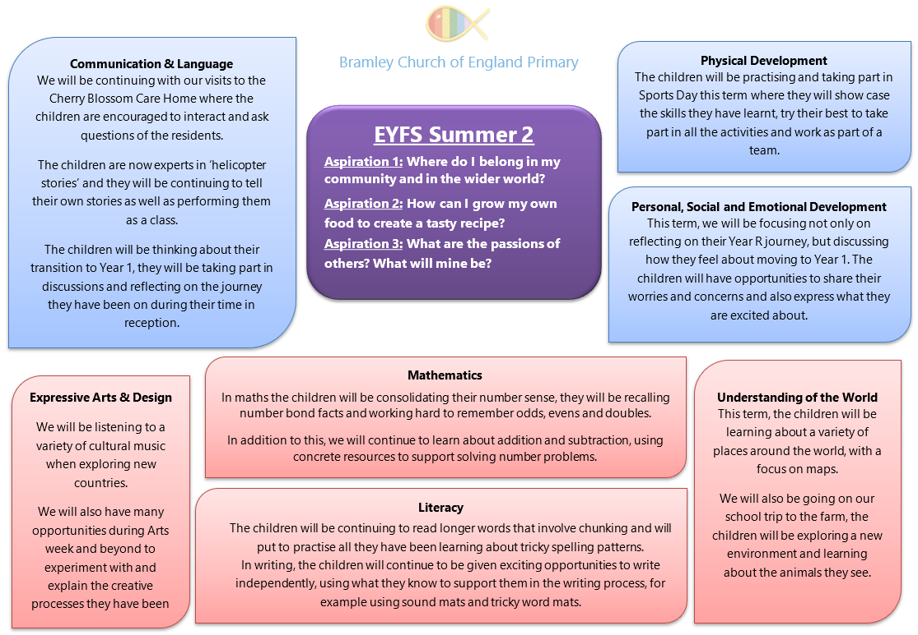**Summer 2 - Learning Overviews**

