**Our Learning Bulletin**

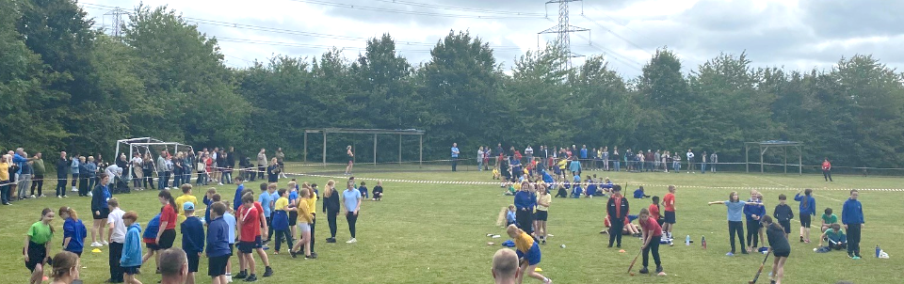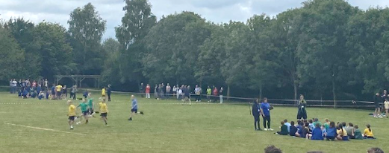I’m writing this tired but smiling after a terrific day of fun and friendly competition. I hope you all enjoyed our Sports Day as much as we did. We recognise that it’s a day which many look forward to, whilst others less so. All we ask is that our children give it their best efforts and show our values by encouraging others and showing sportsmanship throughout.

I can honestly say that every child ticked these two boxes and we are incredibly proud of every one of them.

**BSA Friday Funday…**

Firstly, a huge thank you to everyone in the BSA committee for what must have been months of hard work and dedication to prepare for a fantastic event! It is such a great opportunity for the school and wider community to come together and the buzz around the playground and field was lovely. Thank you also to all the families who came along, played some games, enjoyed the entertainment and had a burger – all of these things helped to raise money for our school.

**Swap Shop…**

Please keep in mind donating any uniform or PE kit your child has grown out of at the end of this term so that it can be put to good use for those who need it. Please remember it needs to be ***in good, clean condition*** *– items you would gladly take home and use for your own children.* Please bring items into the school office next week or drop them off on the first 2 days of the summer holidays.

We will have tables of clothing outside the front of the school on Monday 22nd and Tuesday 23rd July for families to come and collect anything they need ready for September.

**Uniform Expectations in September…**

I am sure many of your will be getting organised over the summer and may need to buy some new elements of school uniform. A reminder of the standard uniform is below – it has not changed from this year.

* Trousers, Shorts or skirt - Grey or black OR *blue/white gingham check dress* Summer Dress
* White Shirt or Polo Shirt
* *Preferably* - School sweatshirt/cardigan or a*lternatively* – plain royal blue sweatshirt or cardigan
* Plain, sensible, black, low heeled shoes or boots for the winter

**Change to PE Kit…**

After the lockdowns, we asked children to come into school wearing their PE kit on the days they had PE. This has had several benefits and is something that is here to stay. As a result, we are changing some of our expectations for PE kit in order to get consistency across the school when children have PE.

******We will no longer be allowing children to wear blue or black hoodies into school on PE days. It is very difficult to ‘regulate’ these items, and unfortunately, the lack of structure can make children seem less tidy on these days and it often feels like a non-uniform day. We have asked our school kit suppliers to start selling Bramley hoodies, zip up tops and fleeces which children can wear on PE days. We completely understand if you are reluctant to purchase a new top like this, so children can wear their normal school jumpers if you’d prefer. The jumpers and cardigans are made of sweatshirt material, and therefore they are suitable for PE. This will help to keep all children in ‘uniform’ and consistently smart all of the time. All of our uniform is available from SkoolKit in Basingstoke or on their website [www.skoolkit.co.uk/school-uniform/140](https://www.skoolkit.co.uk/school-uniform/140) or online from macpac.



You are able to buy plain blue t-shirts or polo shirts for PE, but our providers supply ones with logos if you wanted.

***We are sharing our learning this term through pictures, we hope you enjoy seeing what we have all been up to!***

**EYFS…**

|  |  |  |
| --- | --- | --- |
| *The children have been looking at a range of maps and then we spent time creating our own.* | *Using strips of coloured paper, we made beautiful suncatchers and decorated our classroom windows.* | *We have been learning about bees and how they get the pollen from flowers – the children have decorated their classroom doors to show the importance of saving the bees.* |
| *We had a wonderful day at Finkley Down Farm, petting ponies and rabbits, watching the pigs and meerkats and exploring the farm.*      We | | |

**Year 1…**

|  |  |  |
| --- | --- | --- |
| *Our topic this term is Through the Decades, we have created an amazing timeline to help us to understand what has happened in the past.* | | *We had a fantastic day at Milestones museum – experienceing what life was like in the past by looking at and playing with artefacts.*  *It was fantastic to have so many grown-ups join us to play ‘old-fashioned’ games for our outcome event.* |
| *We explored a range of apparatus in our last gymnastics session of the year.* | *In maths, we have been looking at freactions and cutting or colouring parts of a shape.* |

**Year 2…**

|  |  |
| --- | --- |
| *We practised our cutting skills when we made our own fruit salads in class.* | *Year 2 had such a fantastic day when we went to Wellington Country Park – searching for minibeasts, exploring the grounds and playing with our friends.* |
| *The children have loved exploring our school grounds as part of the Heavenly Hampshire topic. We went on a ‘Bug Hunt’ in forest school to try to find a range of minibeasts.* |

**Year 3…**

|  |  |
| --- | --- |
| *We have been exploring abstract art and made our own versions of balanced, healthy eating plates.* | *We have spent time looking at different sandwich fillings and evaluated what a healthy sandwich might contain.* |
| *As part of our geography work, we have been exploring where fruit comes from around the world.*    The children have designed their sandwiches and are really looking forward to making them with their grown-ups. |

**Year 4…**

|  |  |  |  |
| --- | --- | --- | --- |
| *We had great fun imagining and creating our own dragons ready to write fact files – using How to Train a Dragon as inspiration.* | | *In Geography, the children have been learning to read OS maps and the range of symbols.* | *Our maths works this term has been quite tricky – trying to find equivalent fractions and finding tenths of numbers.* |
| *Scratch has been a fantastic challenge – the chidlren are making their own games using loops.* | *All of the children have thrown themselves into our Viking topic this term! We have made our own mini shields in class. On our trip to Ufton Court, the children loved the weapons practise and tactical battle activities.* | | |

**Year 5…**

|  |  |  |
| --- | --- | --- |
| *To start off the term, we created theme maps of India.*  *Helping the children to understand what life is like in different areas.* | *It has been fantastic to let the children’s descriptive writing skills run wild to describe the very contrasting parts of India.* | *The children have shown such a range of skills by creating fact files showcasing all of the information they have learnt across the term.* |
| *Developing their team work and planning skills, they have created models of the Taj Mahal out of ‘junk’. They also had to work on their adapting and resilience skills!* | |

**Year 6…**

|  |  |
| --- | --- |
| *All children from Church schools across Hampshire have the wonderful opportunity to attend a special Leavers’ Service at Winchester Cathedral. The awe and amazement on our children’s faces during the service and when we walked around was spectacular.* | *In amongst the fun and celebrations, we have continued our learning. In maths, we have been problem solving linked to recipes and bakery! Our writing has centered around prayers and memories ahead of our leavers assemblies.* |
| *Our end of year performance at the Haymarket was truly magical!*  *The children’s confidence and enthusiasm shone through. ‘Sherlock and Cinders’ was a triumph!* |

It has been a wonderful and busy term and we still have lots more to squeeze in. With only one week to go, I would really appreciate it if you manage to find time to thank the adults who have supported your child this year. They all work incredibly hard and put hours in way beyond what I actually pay them for! Your support and appreciation means a huge amount, and the words ‘Thank you’ go a really long way.

I hope you all have a restful weekend.

Take care



Mr Steve Moore

Executive Head of School

**Inset Day for 2024/25**

* Monday 2nd September 2024
* Friday 25th October 2024
* Monday 24th February 2025
* Monday 21st July 2025
* Tuesday 22nd July 2025

**Diary Dates**

|  |  |
| --- | --- |
| **Week 7** | **Little Wandle Assessments Attendance Analysis** |
| 15.7 | Year 6 Trip to Paulton’s Park  Year 3 Outcome event at 2:15pm  ***All children to bring in carrier bags*** |
| 16.7 | BGT KS1+EYFS 9:30 in Hall  BGT KS2 1:30 in Hall  Reports Sent Home |
| 17.7 | 9:30 Yr6 / Yr5 – Leavers service at Church ***Parent volunteers needed please***  Values Reward Bowling Afternoon |
| 18.7 |  |
| 19.7 | Year 6 Leavers Assembly  **Last Day of school year** |
| 2.9 | Inset Day |
| 3.9 | First day of Autumn Term 2024 |