
Bramley Church of England Primary School

APPROVED

Date: February 2022

Next Review Date February 2024

Off-Site Activities and Educational Visits Guidelines

At Bramley C of E Primary School we aim to give our children a broad and balanced curriculum. We believe that children learn best by first hand experiences and as part of this we recognise the value of off site educational trips and activities. The safety of children, staff and parents is paramount, the policy and procedures are formulated in conjunction with the advice, guidance and training provided by Hampshire Outdoor Education, PE and DofE Service and their documentation and guidance. We have a designated Educational Visits Co-ordinator, Mrs Alison Tarrant.

Rationale for learning
Our values and beliefs about the curriculum are supported by off site educational visits through:
- Developing key skills
- Raising self-esteem and motivation
- Developing our social skills and citizenship
- Promoting learning
- Promoting health and fitness.
- Learning through first hand experiences

This is supported by
- High expectations of good behaviour in accordance with our behaviour policy.
- A set of clearly defined roles and responsibilities.
- Parents and others fully informed of the nature and value of the venture.

Key Policies for Consideration
This policy should be read in conjunction with other school policies. Off site visits and educational visits are fully integrated into the ethos and culture of the school and all key policies are considered for their relevance and adaptations or agreements made as required, in particular:

- Teaching and Learning policy – outlining challenge and expectations on educational visits
- Behaviour policy – rights, respect and responsibility of pupils, staff and volunteers. An agreed code of conduct for educational visits and management strategies to employ on visits
- Safeguarding policy – having emergency contact details to report concerns
- Emergency/critical incident planning – including having emergency contact details and instructions on what to do in the event of an emergency
- Administering medicine – identify needs of the group, ensure medicines are taken and delivered as appropriate
- First aid – identify first aid trained staff and provide adequate resources
Many straightforward visits are entirely managed in accordance with these policies and, apart from simple additional considerations, are managed as they would be in school contexts. For all visits the RA and visit plan will highlight any changes to these policies and what to do in those circumstances. We aim to take the ethos, culture and challenge to learning in school into all of our outdoor learning and off site activities.

Types of Visits and Ventures
- On site, out of classroom activities including Iron Age workshops
- Local ventures including walks to the Church and local shops
- Off site day activities including visits to Marwell Zoo, Wellington Country Park and Silchester
- Residential ventures to Marchants Hill and Gordon Brown Centre
- Special events – ad hoc events
- Developing Cultural Capital – planned events
- Sports events – various sporting events
- School visits – transition days etc

For a list of planned visits for this academic year, please see Appendix 1. All visits are approved by Executive Head/Head of School and governors annually.

Organisation and Responsibilities
Responsibilities are in accordance with Hampshire County Guidance, National Guidance (https://opapng.info/) and the Supplementary Employer Guidance from the Outdoor Education, PE and DofE Service.

Executive Headteacher:
- To ensure that all staff have access to guidance, relevant documentation, and training as required.
- To ensure that risk assessment and management strategies are in place.
- To ensure that activities are monitored and evaluated to maintain good practice.
- To appoint a leader for each activity.

Educational Visits Co-ordinator
- To ensure guidance and regulations are followed
- To work alongside trip leaders
- To support the Executive Headteacher or Head of School in decision making
- To ensure risk assessments are carried out.
- To recommend training.
- To support the use of school policies off site.
- To ensure there is liaison and consent of parents
- To support the Executive Headteacher in the management of educational visits
- To be fully aware of the responsibilities of those on educational visits
- To inform the Governing Body as needed.
- To monitor procedures and practice.

The Group leader has responsibility for:
- The administration, programme, supervision and conduct of the educational visit.
- Putting risk assessment procedures in place –location, groups travelling, transport
- Ensuring that volunteers and other adults know:
    - behaviour expectations,
    - supervision strategies while travelling and on location,
    - who they report to and work with
    - their exact role and responsibility
    - understand their duty of care

For a list of procedures, please see Appendix 2.

Risk-Benefit Assessment
As part of the planning procedure for an off site activity, an analysis of the benefits of the activity will be made, translated into objectives and expectations. An assessment of the risk of harm and its likelihood will also be made, followed by putting clear control measures in place so that they can be satisfactorily managed.

A pre-visit inspection by key staff should take place, to review the location and identify management options. Very well-known and used sites may be checked by contacting key personnel prior to re-visiting and accessing web-based information.

Communicating with Parents
When pupils join our school, consent is sought for local visits (within walking distance). Details of on-site and local outdoor learning is provided in our school information and on our website. Consent is checked annually, with parents having the opportunity to change levels of consent. Parents are given a contact information sheet to update annually with any changes. For day or residential activities, additional consent forms are provided to parents. Children cannot attend the visit if they do not have a signed consent form.

Costs and Value for Money (see Inclusion)
The visit letter wold also contain information on the cost of the trip and a request for voluntary contributions. The letter would also state that if insufficient contributions are received the visit may be cancelled. The visits must be value for money, parents are asked to contribute to the cost of transport and entrance fees.

Medical Information
We check medical information annually with the medical questionnaire. For residential and off site activities where additional consent has been sought, the consent form will also check medical requirements. An additional medical form is provided to all parents to complete for residential activities.

Incidents and Emergencies
Guidance from the Outdoor Education, PE and DofE Services is used to prepare leader and base-contact checklist and contact details. The incident management checklist is also available for use.

The Children’s Services Incident and Emergency ‘Establishment Plan’ has been used as the basis for all incident and emergency responses.

Any concerns or ‘near misses’ are discussed to consider changing strategies and reported to the Outdoor Education, PE and DofE Service where necessary or if the information is useful.

Monitoring and Review
The schools monitoring policy has been approved by the senior management team and governing body, and is reviewed according to agreed procedures. This includes outdoor learning/off site and educational visits.

Individual staff reviews contribute to the feedback on the quality of ventures and recommendations for the future.

The head reports to governors on an annual basis as to the effectiveness of the overall programme.

Any good practice is celebrated and complaints reviewed through meetings.

This policy is reviewed every three years or as required if regulations, guidance or circumstances change.

Insurance
The school holds relevant insurance for off site activities through HCC. The school holds additional insurance for the school minibus.

Transport
A variety of transport is used for educational visits following local guidance. Transport used includes:
- parents cars – used to transport own children
- staff cars – used to transport small groups (only with relevant insurance and documents)
- coaches (recognised suppliers) – used for the majority of off site activities
- Trains – used for some activities including the Year 6 performance dress rehearsal. Tickets are booked in advance with collaboration of the local train station
- minibuses for small group transport – used for sport events, choir etc staff drive the school minibus, staff must have a valid licence and have undertaken training to show competence

Supervision
Supervision strategies are dependent on the typical risk factors of the group or individuals concerned, the site or location, the leaders present (including ratios) and other factors such as transport or weather etc. these are agreed as part of the planning process and can be adapted to changing circumstances, for example clear ‘Plan B’ alternatives, when it is necessary or prudent to do so.

Supervision strategies to be used include:
- Adult to child ratios
- Rationale for supervision in different contexts eg at the venue, on excursions, during activities, when travelling, when eating etc
- Information available and with whom (base contacts, lists, telephone trees) for parents

In accordance with county guidelines (HCC supplementary employer guidance) the ratios are:
- under 5s - 1:6
- Under 8s - 1:8
- From 8-18 - 1:12

These are a minimum requirement for all trips. However we aim to exceed these whenever possible.

Inclusion
This is an inclusive school and we aim to ensure that all pupils are treated fairly and are able to engage in our activities. Where we have pupils with additional needs, we will seek out alternative (where available) to ensure that every child has the same chance at experiences. This may include changing venues (for example changing a residential venue to one with disabled access), offering alternative activities at a venue, changing the staffing ratio to allow for 1-1 supervision and as a last resort, inviting parents to assist with a visit to help ensure behaviour requirements.

The health and safety of the child concerned and their effect on other children and staff will play a significant role in inclusion discussions. Any decision on inclusion when such factors are included must, as normal, take ‘every reasonable step’ to include that young person. However if those reasonable steps cannot ensure their safety and/or that of others, then that may be the reason they cannot attend that particular venture.

There are differences between the scopes of different styles of venture in relation to inclusion. Activities provided as part of the National Curriculum such as swimming, are provided free of charge to parents as they form part of our statutory requirements. We have a statutory requirement to provide inclusion to all.

Ventures where comprehensive coverage, for example a whole class or group, is desirable but suitable alternatives are available at school where National Curriculum and similar entitlement is not lost as this is an enhancement activity, does not require full inclusion. In these situations, inclusion is desirable but not required. Children/parents can choose not to attend these activities and voluntary contributions are sought to help pay for them. Choice or other factors may mean that not all attend. Where available, we aim to allow everyone the opportunity to attend these events, irrespective of financial background and ability.

Enhancement or enrichment activities that are purely additional are optional, for these events the full cost is paid by the parent as attendance is not compulsory. Choice and other factors will mean that not all attend.

Safeguarding
The school’s safeguarding policy follows and includes off-site activities including residential activity. In particular:
- Guidance on acceptable behaviour and avoiding unnecessary contact
- Suitable ‘employment’ checks are made on volunteers and other responsible adults who support these ventures in line with guidance (eg the degree of monitoring, frequency and intensity of contact), including DBS requirements
- External providers or outdoor centres are drawn from the Outdoor Education, PE and DofE Services checked providers list, which confirms that safety management checks are in place
- If external providers are not on the checked list, reference would be made to the Outdoor Education, PE and DofE Services to ensure suitable steps are taken

Appendix 1 – Proposed Visits for 2021-22
Curriculum Events and Trips 2021-22
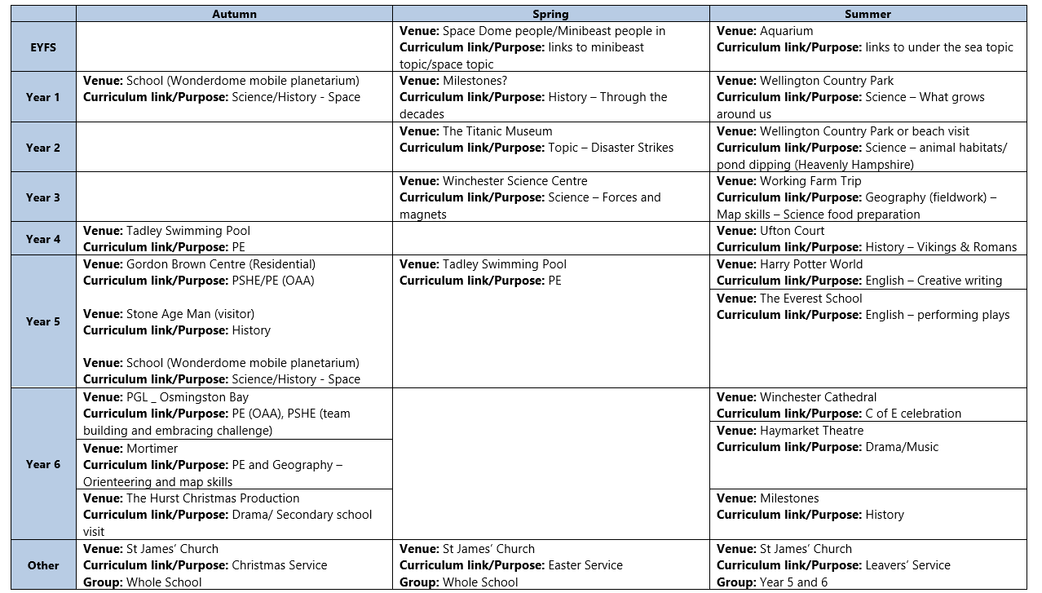
Appendix 2 - Procedures

  - The trip is registered on the EVLOVE website and the EVC can access plans there.
  - Details are agreed upon and arrangements made.
  - A risk assessment is completed, with copy given to E.V.C.
  - EVOLVE forms to be submitted 6 weeks before the trip
  - The trip leader liaises with the Executive headteacher/Head of School and Office staff to confirm the following:
    - Accept quotes
    - Place orders
    - Review risk assessment
    - Send out consent forms
    - Review and confirm medical/ emergency procedures including special needs.
    - Arrange for names and telephone lists of helpers for staff/helpers
    - Confirm supervision strategies.
    - Confirm site details and eating arrangements.

  - Prior to the trip the leader holds a meeting with class teachers and support staff to:
- Confirm all details
- Check and chase up consent forms and money
- Answer any questions
- Confirm eating arrangements and requirements
- Check medical needs and first aid– ask parents to provide personal Epipens if necessary
- Check first aid bags are stocked and ready to go
- Agree timetable and emergency arrangements
- Organise lists of emergency contacts for all staff, volunteers and pupils attending the visit
- Issue information packs

  - On the day:
- Remind children what is expected of them
- Confirm groups and allocate helpers
- Pick up first aid bags and coach first aid supplies
- Ensure office has required information – telephone and emergency numbers, list of helpers, emergency procedures etc
- Ensure helpers have information packs and risk assessments
- All children to visit the toilet
- Check all children have brought a packed lunch/water
- Check each coach has medical/ first aid needs – ask parents to provide personal Epipens if necessary
- Check children onto coach and seatbelts
- Ensure adults are evenly spread around and aware of which group of children they are supervising

At the venue
- Check children on/off coach
- Explain again purpose of visit and expectations of behaviour
- Check groups arrangements and meeting places/times

Back at school
- All children to be taken to own classroom for collection by parent/carer
- Medical/first aid items to be returned to medical room and stock replaced if needed
- All consent forms and trip related paperwork to go to EVC in office to file, any extra copies to be securely disposed of
- EVC to be informed of any medical concerns that arose on the visit and forms completed as required
- Trip leader to evaluate the trip on EVOLVE

Further guidance and advice
- National Guidance http://oeapng.info
- High Quality Outdoor Learning (English Outdoor Council, Outdoor Education Advisers’ Panel et al 2015) can be found on EVOLVE
- Trailblazers Project
- Council for Learning Outside the Classroom www.lotc.org.uk

