**What are we learning?**

The new year has started brilliantly – school has a wonderful buzz of learning in every classroom! The children have immersed themselves in their new topics: learning new facts and exploring new ideas. The first newsletter of each term will contain the topic overviews for every year group, mapping out the learning for this half term. Where we can, we try to link different aspects of the learning to the main driver, usually a history or geography focus, to enrich the curriculum but some subjects stand alone in order to best meet the learning objectives.

Within all learning opportunities at school, we strive to embed our key learning behaviours. We believe that when children have practised and secured these skills, they would be able to thrive in different environments and become lifelong learners.

Hopefully the children have already come home this term and shared that our animals have had a bit of a revamp – we are excited to unveil their new Bramley look:

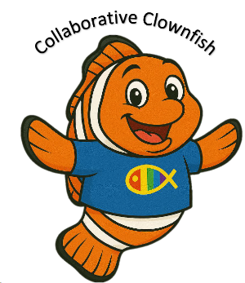







**Autumn Term Diary Dates**

At the end of the bulletin, we have also mapped out the key dates for the Autumn term. We know that for many parents organising work or childcare to be able to attend school events can be tricky, so we are trying to give as much advanced notice as we can.

**Inset Day for 2025/26**

* Friday 10th October 2025
* Monday 23rd February 2026
* Friday 22nd May 2026
* Monday 22nd July 2026

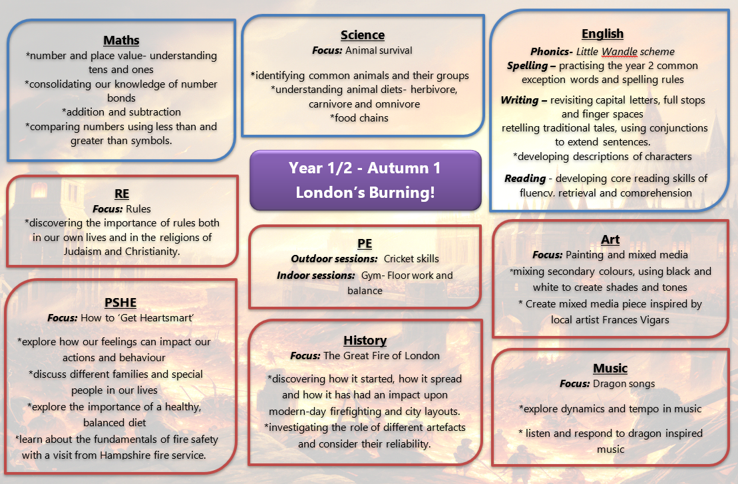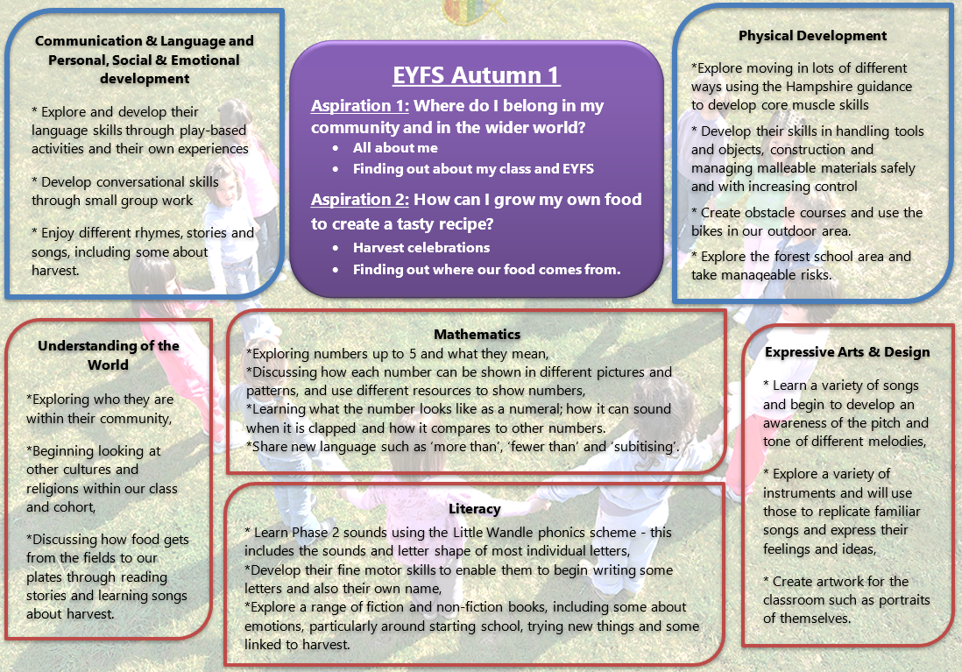:

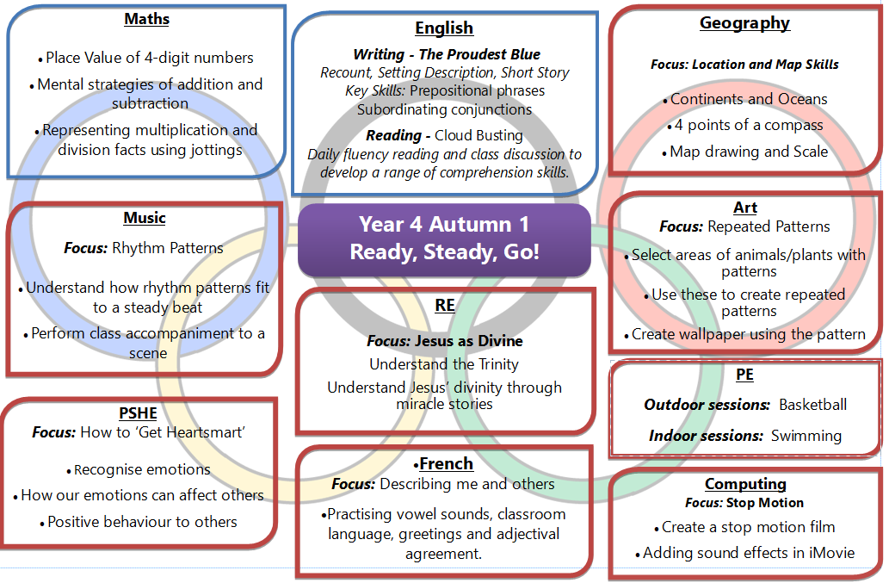 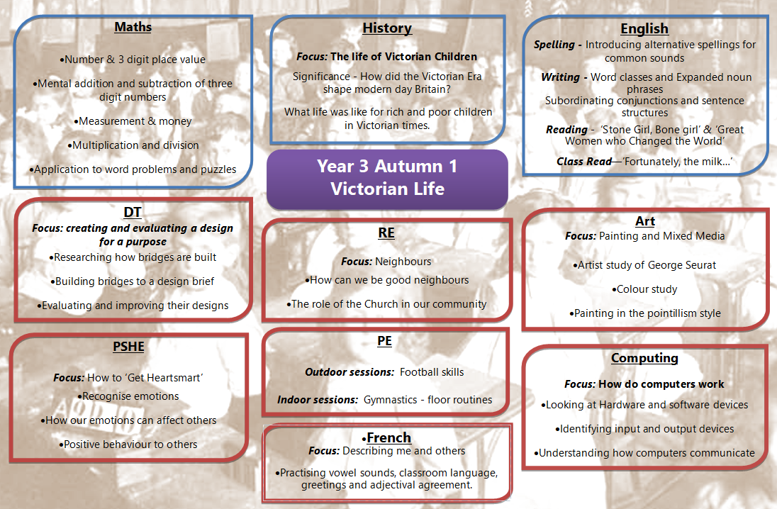

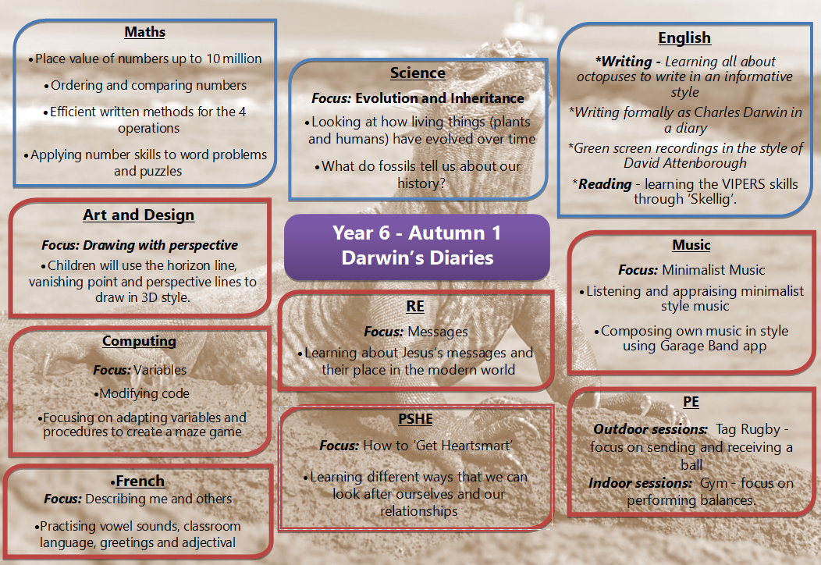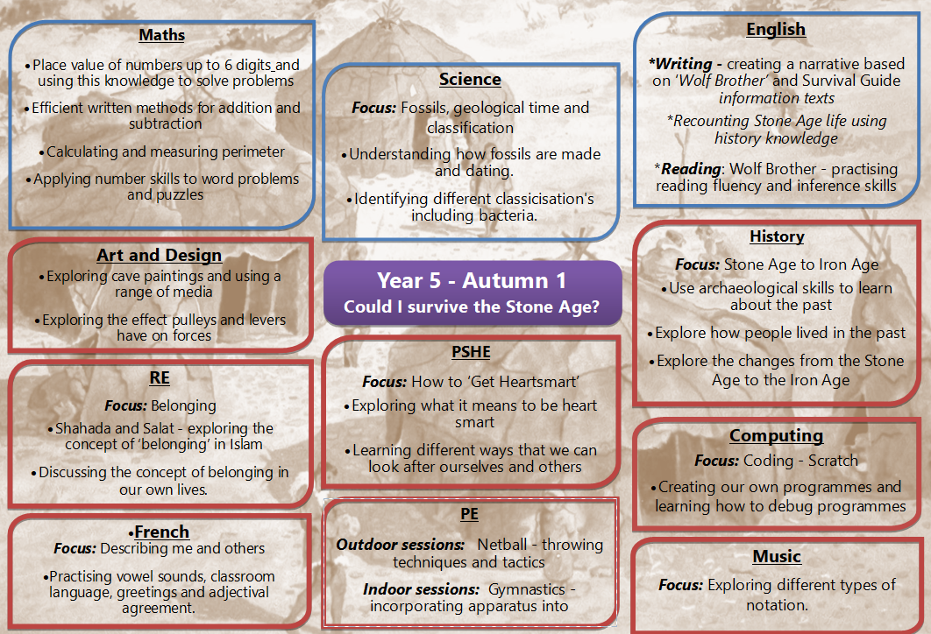

**Autumn Term Key dates:**

|  |  |  |
| --- | --- | --- |
| ***Week*** | ***Date*** | ***Event*** |
| **2** | 12.9.25 | New EYFS first day  Yr5 Iron Age Day |
| **3** | 15.9.25  16.9.25  17.9.25  18.9.25  19.9.25 | Yr6 Residential to Osmington Bay  Yr4 Swimming Starts *– Morpurgo and Cowell*  Yr3/4 Parent Information Meeting 3:30 – *Cowell class*  Yr1/2 Parent Information Meeting 3:30 - *Gray and Gravett class*  Yr4 Swimming Starts *– Rauf* |
| **4** | 22.9.25  23.9.25  24.9.25  25.9.25  26.9.25 | House Captain Elections – *Children in Yr1-6 in house colour t-shirts + uniform* |
| **5** | 29.9.25  30.9.25  1.10.25  2.10.25  3.10.25 | KS2 Golf Session *- Children in Yr3-6 in PE kit*  Yr5 Residential to Gordon Brown Centre |
| **6** | 6.10.25  7.10.25  8.10.25  9.10.25  10.10.25 | Inset Day |
| **7** | 13.10.25  14.10.25  15.10.25  16.10.25  17.10.25 | Yr4 Outcome event *- parents invited afternoon*  Open Morning 9am – *EYFS cohort 2026*  Parent’s Evening booking system goes live at 4pm  Harvest Service - *Donations for the food bank*  Open Morning 9am – *EYFS cohort 2026* |
| **8** | 20.10.25  21.10.25  22.10.25  23.10.25  24.10.25 | Open Morning 9am – *EYFS cohort 2026*  Yr3 Victorian Day  Yr3 Outcome event *– parents invited afternoon*  Yr2 Outcome event *– parents invited morning*  Flu Vaccinations by school nursing team – *all years*  Values Day – Being Confidently Me |
|  | **Half Term 27th Oct – 31st Oct** | |
| **1** | 3.11.25  4.11.25  5.11.25  6.11.25  7.11.25 | STEM Week – Global Goals  Open Morning 9am – *EYFS cohort 2026* |
| **2** | 10.11.25  11.11.25  12.11.25  13.11.25  14.11.25 | Parent’s Evening 3:30 – 6pm  Parent’s Evening 3:30 – 6pm  Parent’s Evening 3:30 – 6pm  Values Day – Making a Difference |
| **3** | 17.11.25  18.11.25  19.11.25  20.11.25  21.11.25 | School Photos – *Individuals and siblings* |
| **4** | 24.11.25  25.11.25  26.11.25  27.11.25  28.11.25 |  |
| **5** | 1.12.25  2.12.25  3.12.25  4.12.25  5.12.25 | EYFS Christmas Performance 10am *– Tiger Class*  EYFS Christmas Performance 10am *– Ladybird Class*  EYFS Christmas Performance 10am *– Puffin Class* |
| **6** | 8.12.25  9.12.25  10.12.25  11.12.25  12.12.25 | Yr5 Outcome event *- parents invited afternoon*  KS1 Christmas Performance *– Dahl, Donaldson and Jeffers Classes*  KS1 Christmas Performance *– Gray and Gravett Classes* |
| **7** | 15.12.25  16.12.25  17.12.25  18.12.25  19.12.25 | Christmas Service  Christmas Lunch  Yr6 Outcome event *- parents invited morning*  Rock Steady Concert 2:15pm *– parents invited*  Christmas Jumper Day  2pm Carols on the Playground |
|  | ***19.12.25*** | ***Last day of Autumn Term*** |
| ***Christmas Holidays 22nd Dec – 2nd Jan*** | | |